Dynamic Stair Trainer 8000 - Triple Pro

All-in-one physical therapy machine
Versatility for Empowerment  DST8000 Triple Pro combines three devices in one, including an adjustable staircase for walking up and down steps, a walking surface Inclined at different angles, and a full horizontal parallel bar. The unit’s sleek versatile design simulates everyday urban terrain – enabling patients to train and practice different slopes, stairs and gaits without changing equipment.  Easy to Adjust and Control  With a click of a button, therapists can adjust the degree of the slope and the height of the stairs. Patients benefits from an optimal training regimen, leading to improved performance in less time and efforts. |  | 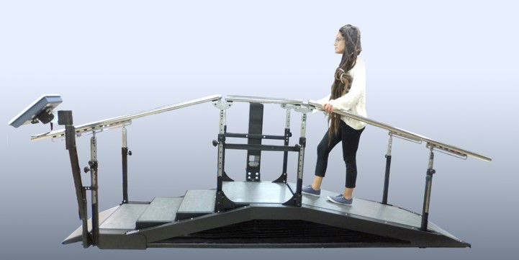  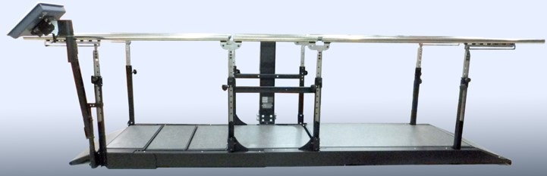

The 3-in-1 Unit measures, displays and documents all treatment sessions, including:
- Time it takes to walk across parallel bar
- Stairs height and time it takes to climb
- Slope degree and time it takes to walk

Specification:
Model: | 8000-Triple-Pro
Flat walking surface: | 3 Meter (9.8 ft.)
Total/Handrails length: | 3.6 Meter (11.8 ft.)
Total width: | 1.6 Meter (5.2 ft.)
Stairs/slope width: | 65 cm (25.6 in.)
Slope angle range: | 0 to 26 degrees
Stairs height: | 0 to 16.5 cm (0 to 6.5 in.)
Handrails height range: | 65-93 cm (25.6-36.6 in.)
Maximum load: | 200 Kg (440 lb.)
Unit weight: | 270 Kg (594 lb.)
Electrical requirements: | 100-240V, 50/60Hz, 4A max
Operating interval: | 2 min on / 18 min off
Worldwide patent; Color, design and spec’ may vary

