NEW
The Swiss Army Knife for your Rehab Clinic
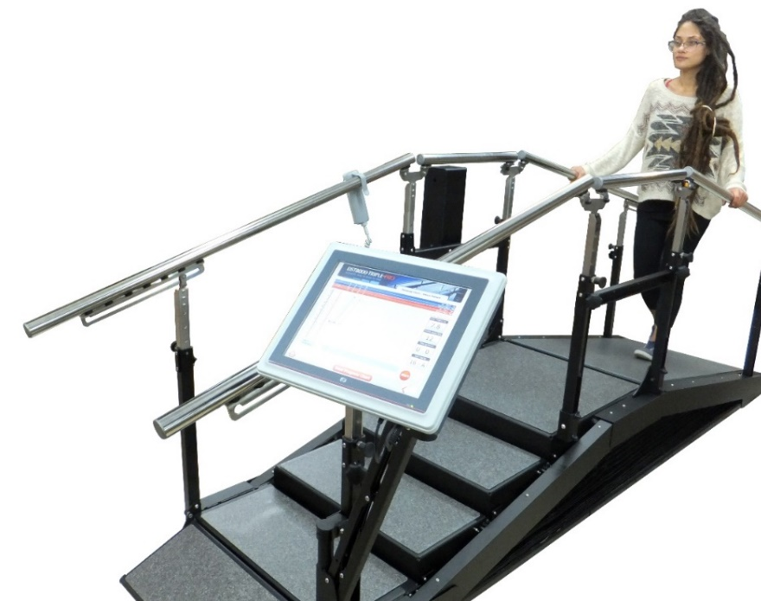
DST Triple Pro
- Powered steps and incline rise and lower to suit clients immediate needs
- Multi-tool for rehab, Steps, Incline and Parallel Bars
- Smart too. CPU captures data and builds reports
- Gait, Balance training, Aerobic Conditioning
- Less cost than 3 separate pieces
- Smaller footprint than 3 pieces
Experience DST Triple Pro at AHCA/NCAL
Booth 1313
Clarke Health Care Products
888-347-4537

