

 SafetyGrip® Bedside Balance Assist Rails

Rails and bars used for assistance while moving, repositioning or sitting up in bed. Assist rails provide stability to balance when standing or transferring from bed.

**HER100** **SafetyGrip®** is a 360° rotating assist rail with both vertical and horizontal grab areas to assists transfer onto and off the bed. Rotation locks every 90⁰. Using various sections, rail is height adjustable from 34.3”-44.12”, can be safely used on all mattress thicknesses and sizes. Vertical and horizontal grab areas with SafetyGrip® coating are 12” long.

Made of steel with white, powder-coat finish, that is anti-microbial and anti-bacterial. Mounts to beds with L-shape angle iron frame. 300 lb. capacity, weighs 19 lbs. 1 year warranty

** HER450 SafetyGrip®** Balance-Assist bedside rail with multiple height adjustment options. Straps around box spring or frame, fits twin to king size beds, mattress height standard to pillow-top. Top of bar sits 14 ¾” above bed frame, additional cross bar adds 5.25” height, standing 20” above the bed frame or box spring. Grab area is 18.25” with patented SafetyGrip® surface.

Made of steel with white, powder-coat finish, that is anti-microbial and anti-bacterial. 300 lb. capacity, weighs 8.3 lb. 1 year warranty



**HSG450** **SafetyGlo®** balance-assist bedside rail with patented SafetyGrip® grab surface which gives a great grip every time. The unique gentle glow assists the user to locate the grip, gain balance and gather their bearings. Glow is engerized by sunlight or room light. Grab area is 18 ¼”. Rail attaches with adjustable traps around bed frame or box spring. Top of bar sits 14 ¾” above bed frame, additional cross bar, included in package adds 5.25” height, standing 20” above the bed frame or box spring.

Made of steel with white, powder-coat finish, that is anti-microbial and anti-bacterial. 300 lb. capacity, weighs 8.3 lb. 1 year warranty

*These products are not intended to be used as bed restraints to keep someone from falling out of bed.*



**70002** **M-Rail®** is an easy bedside mobility solution, fitting snuggly against your mattress and helps you get comfortable, reposition, sit-up, balance, stand or transfer to a chair or wheelchair. M-Rail® fits all mattress sizes. Lightweight, compact, and ideal for both home and travel. Adjustable height from 14.5” to 20” above bed frame. Compact and lightweight, its contoured padded handrail provides a soft, secure grip.

Easy to assemble with no tools required. Made of steel, M-Rail® has a 300lb. capacity, weighs 7 lbs. 1 year warranty.

** 70000** **Arcorail®** is a rotating, professional-grade bedside handrail, which provides maximum bedside mobility for home, clinical care, and hospital settings. Patented rail rotates 360° and locks in place every 90°; totaling four locked positions. Vertical floor tube has multiple height adjustments, 23”-33” and fits all bed sizes. Second loop can be removed for taller mattresses up to 24” high. Arcorail® s surface is treated with an anti-bacterial powder coating.

All components are included to attach securely to a variety of bed frame styles, L-shape, tubular, square or rectangular channels. Arcorail® has a 300 lb. capacity, weighs 20 lbs. 1 year warranty.

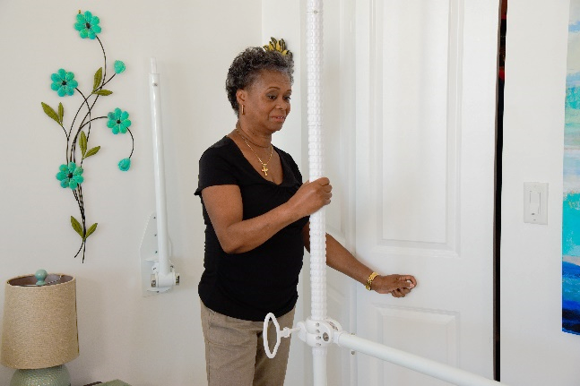**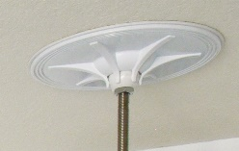 HER611** **MoveEasy**® **Pole** is a free standing vertical pole that securely fixes from the floor to the ceiling, anywhere in a room, as long as it has a regular drywall ceiling attached to wooden or steel studs. Floor plate can be screwed into floor for heavy, aggressive use. Easy to store and put away, its fast removal feature in high-occupancy and rotating facilities makes it ideal for facility or home.

Assembles in sections, steel pole adjusts from 79.5” – 109.5”with 39.25” of SafetyGrip®, patented grab surface. Unlike competitors poles which ship as one 8’ box, longest section is less than 36” for easy transport or storage. 200 lb. capacity, 1 year warranty.

*Photo shows optional horizontal bars not included in HER611.*

|  |  |  |  |  |
| --- | --- | --- | --- | --- |
| **Model** | **Width of grab area** | **Height above mounting point** | **Capacity** | **Mounting style** |
| HER100 | 12” | 34.3”-44.12” | 300 lb. | Mounts to L-shaped angle iron bed frame |
| HER450 | 18.25 | 14.75”/20” | 300 lb. | Strap around box spring or frame, twin to king |
| HSG450 | 18.25” | 14 .75”/20” | 300 lb. | Strap around box spring or frame, twin to ling |
| 70002 | 18” | 14.5”/20” | 300 lb. | Strap around box spring or frame, twin to king |
| 70000 | 14” | 23”-33” | 300 lb. | Mounts to bed frame; L-shaped angle iron, round tube, square or rectangular channel frames |
| HER611 | 39.25” | 79.5”-109.5” | 200 lb. | Pressure fits floor to ceiling |

*These products are not intended to be used as bed restraints to keep someone from falling out of bed.*